Cornell Cooperative Extension, Suffolk County 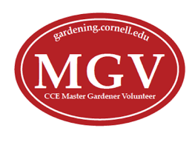 Master Gardener Service Diary
CATEGORIES for REPORTING HOURS and ACTIVITY

1. Adult Education: info tables, teaching SGS, Seed to Supper, public speaking, workshops, demonstrations
2. Youth Education: school gardens, lessons at Children’s Garden or other sites, youth events, public speaking
3. Gardening: beautification or maintenance at MG sites, community gardens, greenhouse, garden projects
4. CCE/MG Support: MG committees, MG projects, SGS, MG Training, CCE website, social media, mass media
5. Continuing Education: attending workshops, programs, courses, in person or online training

Note: ADD YOUR ACTIVITY DESCRIPTIONS ON NEXT PAGE

NAME:
CLASS YEAR:
DATE: Preferred phone:
Hours
Adult Education | Youth Education | Gardening | MG/CCE Support | Continuing Education | Total Hours
 |  |  |  |  | TOTAL

EMAIL TO: mgvsuffolk@cornell.edu “Last name, hours” in the subject line. Thanks!
Adult Education
Youth Education
Gardening
MG/CCE Support
Continuing Education
Cornell Cooperative Extension, Suffolk County Master Gardener Service Diary

NAME:

Site Description/Activity

EMAIL TO: mgvsuffolk@cornell.edu “Last name, hours” in the subject line. Thanks!

