

Teacher/Student Resources

Water Quality
The Science Behind the Solution

Topics: Environmental science, Water Quality, Math, Units and Conversions, Aquaculture, Bivalves,
Food webs, Applied science, Scientific method, Experimental Design

Materials: Digital Education Fact Sheets, scrap paper, calculator, pencil, internet

The Problem:
Long Island’s water bodies were once filled with oysters, clams, scallops, and mussels. These animals are all classified as bivalves. They are also filter feeders, which help keep the bays clean and clear, as they feed on microscopic algae living in the water. Due to a number of human impacts, including overharvesting, water pollution, and habitat loss, all of these bivalves have dramatically decreased in population over the last few decades. Now, Long Island’s bays and their inhabitants suffer from water quality issues, such as low visibility and brown tide (caused by a harmful algae).

The Solution:
Cornell Cooperative Extension Marine Program (CCE) has offered a solution. Skilled technicians and scientists can breed and grow bivalves in a hatchery and nurseries, and then release them to the wild to help rebuild wild populations. This process of raising marine animals in captivity for commercial or environmental purposes is called Aquaculture.

Your Role:
You are an environmental scientist working for CCE Marine Program. You have been tasked with the challenge of informing legislators (law makers) and donors about the need for repopulating Long Island’s bays and estuaries with these important filter feeders. You know that with proper funding and support, CCE can produce 50 million shellfish in one season. The community wants the most cost effective and efficient way of repopulating the bays, as well as a timeline for cleaning up the bays.

You must determine the following:

Part 1: Which species filters the bay water the fastest?

Part 2: How long will it take 50 million of them to filter an entire bay?

Check out our Water Quality fact sheets and videos for some background information before you proceed.
http://ccesuffolk.org/marine/digital-education-initiative/water-quality
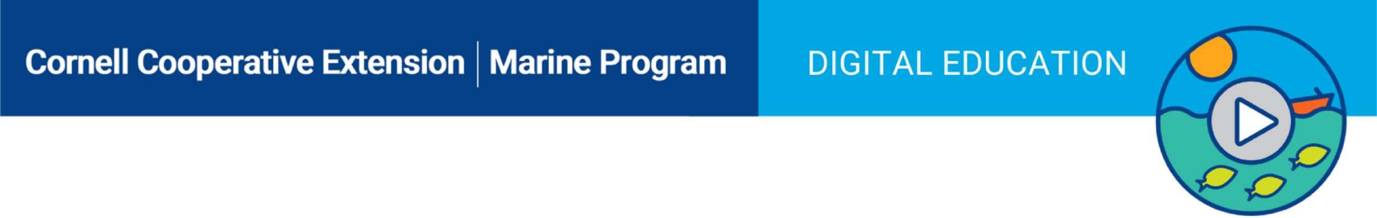

Part 1:
Which species of filter feeder provides the most efficient solution to the problem?

Write your hypothesis here:

Write out the steps to an experiment you could do to determine whether your hypothesis is correct:

We will be focusing on oysters first.

Watch this video: “Oyster Time lapse” - https://youtu.be/DJWbViAkcb0

Let’s assume the method shown in the video is what you will use for your experiment.
In the video, you witnessed a single oyster filtering about 1 Liter of seawater.

The water started out bright green. What caused the green color? (remember what oysters eat)

_____________________

Word Problem: If the video was 30 seconds long, but in real time it took 10 minutes to film, how fast did the
oyster filter 1 Liter of water?

Is there any information given here that you don’t need?_______________

What information do you need to calculate the RATE of filtration? ___________ & ___________

Filtration Rate = Volume of water filtered
Total Time of filtration

Fill in the formula with the information from the word problem, and show your calculation:

Filtration Rate = Volume of water filtered
Total Time of filtration

Filtration rate (per min): The single oyster filtered ___________liters of water per minute (L/min)

It might be more useful to know how much an oyster can filter in one day.
Let’s convert this rate to liters per hour first.
There are 60 minutes in 1 hour, so multiply your previous answer by 60.

Filtration rate (per hr): ________________ (L/min) X 60 (min/hr) = ________________ (L/hr)

There are 24 hours in 1 day, so multiply this new rate by 24.

Filtration rate (per day): _______________ (L/hr) X 24 (hr/day) = _______________ (L/day)

Notice that we measured and calculated volume using LITERS, which is a unit of the metric system. Local legislators and donors will understand these numbers best in the U.S. Imperial System, which uses GALLONS for volume.
So, let’s convert: There are 0.26 gallons in 1 liter.

Filtration rate of a single oyster (expressed in gallons per day):
__________________(L/day) X .26 (gal/L) = ___________________(gal/day)

In this experiment we have only demonstrated the filtration rate for one single oyster. In science it is very important to have a large sample size. This means the experiment should be repeated a large number of times. Each repetition is called a trial. All conditions should be kept the same for each trial to ensure consistency.

What are some conditions that you would have to keep constant in an experiment like this?

Part 1 Conclusion:
To conclude Part 1 we need to compare the daily filtration rate of an oyster
with that of a scallop, clam, and mussel.

Assume that scientists have already determined the daily filtration rates of the following species:
Species | Maximum Filtration Rate
Eastern Oyster | 50 gal/day
Bay Scallop | 40 gal/day
Ribbed Mussel | 40 gal/day
Hard Clam | 10 gal/day

*In reality many of these are up for debate and need further study.

Based on these numbers, was your original hypothesis correct? ___________________

Something else has to be considered. Filtration rates vary within each species. The above table shows “maximum” rates. For example, an oyster can filter “up to” 50 gal per day, but often less than that.

What are some factors that might affect the filtration rate of an individual animal?
(Remember that filtration is actually feeding.)

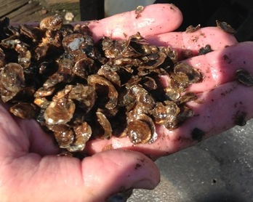
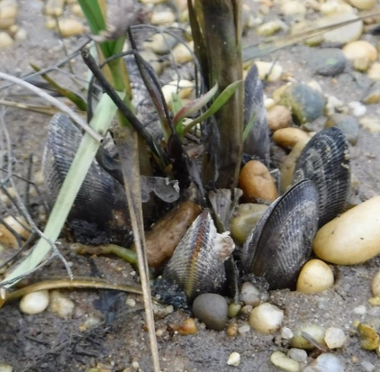
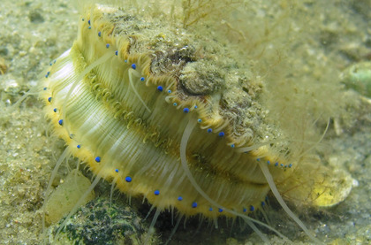
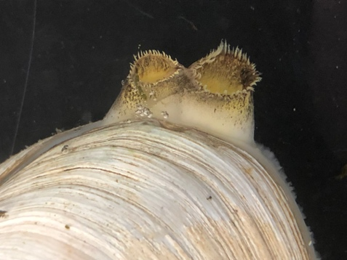

Bay Scallop filtering water. They have blue eyes to sense light.

Baby Oysters

Ribbed Mussels cluster in salt marshes and aid the grass in filtration

Hard Clam filtering by drawing water in through siphon

Part 2:
How long will it take 50 million oysters to filter the entire bay?
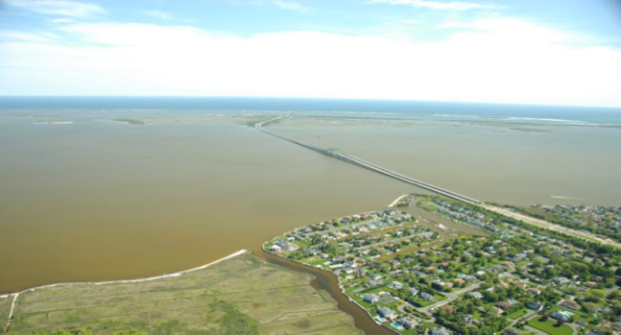
To answer this question, we need to know the volume of the bay. Let’s look at Shinnecock Bay as an example.
We can get an estimate of the volume using this formula:

Volume = Surface area x depth

Using satellite technology we have determined that the surface area of Shinnecock Bay is 16 square miles, which converts to about 450 million square feet (450,000,000). The average depth of the bay is about 8 feet.
Brown tide in Shinnecock Bay, Shinnecock Bay Restoration Program

You can check this calculation yourself by filling in the formula, but here it has been done for you:

The volume of Shinnecock Bay is 3,600,000,000 cubic feet.
We can write this as 3.6 billion cubic feet.

Now, let’s convert from cubic feet to gallons.
There are 7.5 gallons in 1 cubic foot, so multiply the above volume by 7.5 gallons.

There are ____________________ billion gallons of water in Great South Bay.

So how long will it take 50 million oysters to filter this bay?
Recall from Part 1 that a single oyster can filter up to 50 gallons of water per day. This multiplied by 50,000,000 (50 million) will give you the daily filtration rate of 50 million oysters.

So, the filtration rate of 50 million oysters is 2.5 billion gallons per day.

Time to filter entire bay = Volume of Bay
Filtration rate

Use the above formula to find your conclusion to Part 2:

It will take 50 million oysters ___________________days to filter all of Great South Bay.

Final Conclusion
Before you draw your final recommendation, there is a little more to this story.

First, you have learned that there is variation in filtration rate among bivalve species and even within a single species. Size and maturity are major factors. You may have listed even more.
(Slowest) (Fastest)
Order of growth rates: Hard Clam → Ribbed Mussel → Oyster → Bay Scallop

There is also a benefit to maintaining high biodiversity in an ecosystem. Biodiversity is the total number of different species living in an area. The more species, the more options in the food web. Biodiversity can also protect against catastrophes. A disease could come through and kill off all of the bay scallops at once, but perhaps oysters and clams are immune to this disease. A hurricane may break through a barrier beach, like Fire Island, flooding the bay with salty ocean water. Oysters are finicky and need brackish water, somewhere between freshwater and ocean salinity.

Use the experimental results, calculations, and background information to write your official recommendation to your community, legislators, and donors.

For more information about shellfish roles in water quality, explore these resources.
https://www.fisheries.noaa.gov/national/habitat-conservation/oyster-reef-habitat
https://lishellfishrestorationproject.org/
http://ccesuffolk.org/marine/aquaculture/
http://shellfish.ifas.ufl.edu/environmental-benefits//#Filtration
https://www.chesapeakebay.net/S=0/fieldguide/critter/atlantic_ribbed_mussel

